**Old vs New FlexFlexsEMG Responses to Signals from a Wave Generator**

Pragathi Venkatesh

Background Information/Goals:

The second set of clinical trials with the FlexsEMG had differing results from the previous set of trials done only on Arsalan’s bicep.

1) SNR varied between greatly between all channels, ranging from 2 to 60 dB, whereas previous tests showed a consistent SNR around 30-40 dB (on an older sample).

2) Even after increasing the sampling rate from 600 Hz to 1000 Hz, the measured MCV was less accurate, being 5 times greater than the average MCV in humans

Possible causes include electrode degradation after multiple uses and incorrect postprocessing methods (perhaps different FlexsEMG devices require different noise filtering methods). To identify the cause, controlled signals from a waveform generator will be fed into the FlexsEMG electrodes to see if the FlexsEMG output matches the Waveform Generator output. If the signals do not match, we will attempt to create postprocessing methods to make these signals match (if at all possible).

Setup:

|  |  |
| --- | --- |
|  | Some specs:   * AD2 sampling rate: 10000 Hz * FlexsEMG sample #5: used in clinical trials for 2 subjects (FC and MSJ). Sampling rate: 1000 Hz * FlexsEMG sample #6: used in clinical trials for the remaining 5 subjects * FlexsEMG sample #7: new sample, Sampling rate: 1500 Hz |

Each electrode was contacted by another gold electrode as to not scratch the electrodes. This had no effect on the wave generator output.

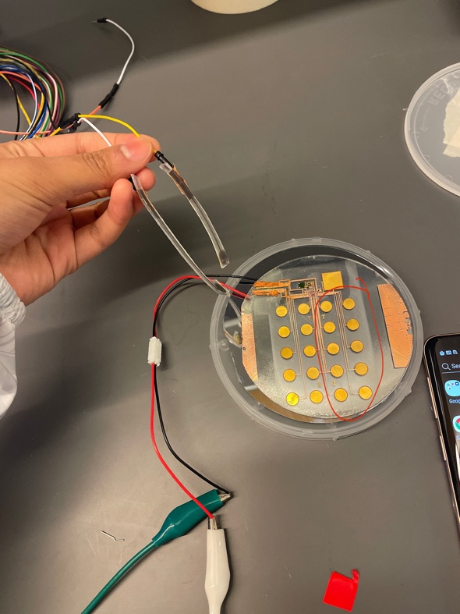 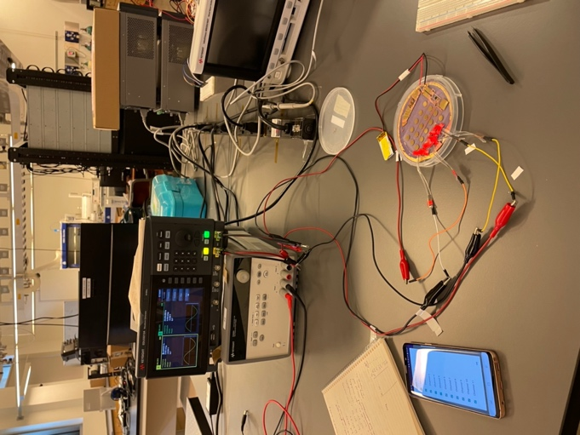 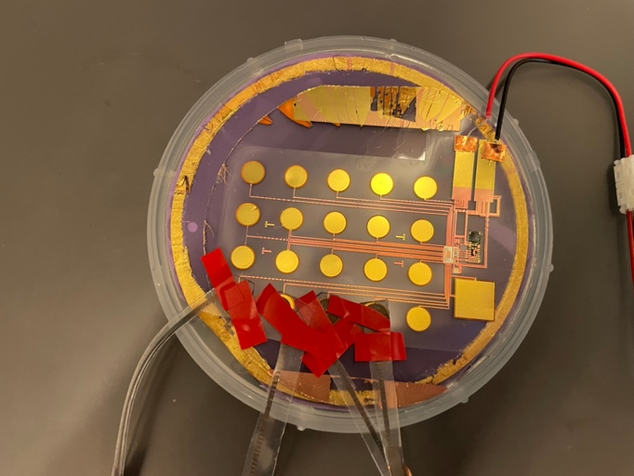

A. Sample #7 Noise Profiles

FFT of noise from Sample #7 (the unused one). Each noise measurement was 2 minutes long, taken right after each other.

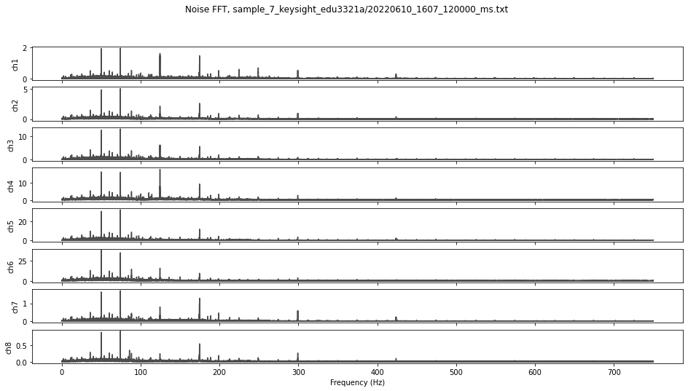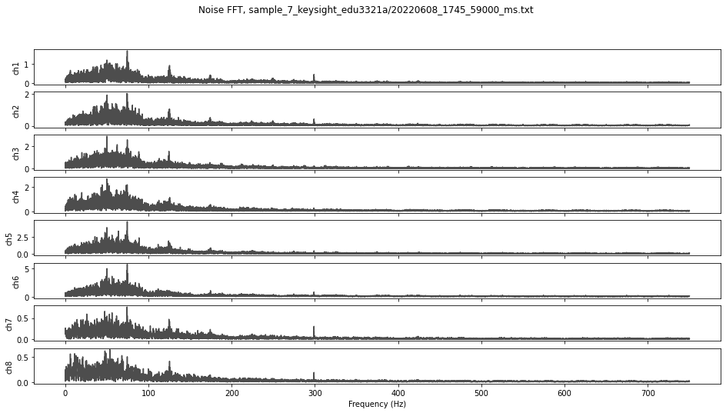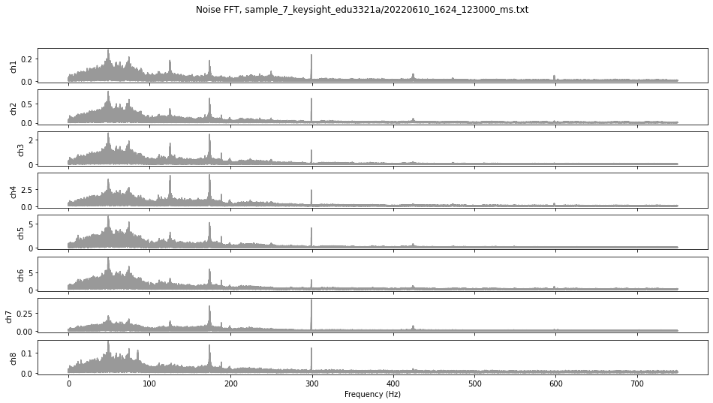

**FFT Amplitude**

**Frequency (Hz)**

Raw Noise Signals

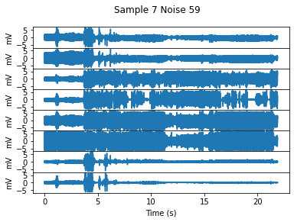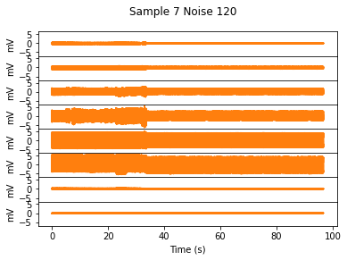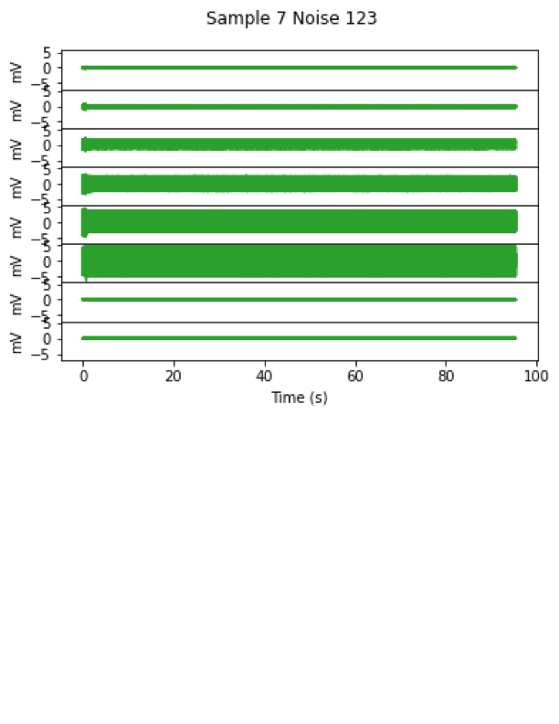

The left plot (in blue) contains movement artifacts due to my pushing down on the electrode. This demonstrates that some electrodes are consistently much noisier than other electrodes, even in new samples. The peak noise frequencies for sample #7 appear to be at 50, 75, 125, 175, and 300 Hz.

B. Drafting a noise filter based on 200 Hz response

With sample 7, we fed sine waveforms with 50, 100, 150, 200, 250, and 275 Hz frequencies with a 3mVpp amplitude and 0 phase offset (at first). Since Sample #7 has significant noise at 50 Hz, we will not analyze the measurement at 50 Hz for now.

200 Hz analysis, fed into channel 4:

|  |  |
| --- | --- |
| figures/sample_7_200Hz_response_fft.png | Raw Signal |

Here, a 200 Hz signal was fed into the +ive and -ive electrodes of channel 4. While the FlexsEMG response has no phase difference, the amplitude response varies, reducing the 3mVpp input into a 2.5-3 mVpp output. Adding 5th-order IIR notch filters at 50 and 75 Hz do little to improve the response.

Responses for 100, 250, and 275 Hz sine inputs:

**100 Hz:**

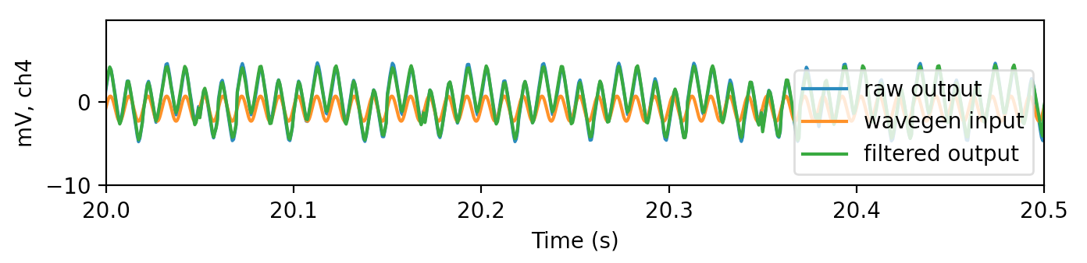

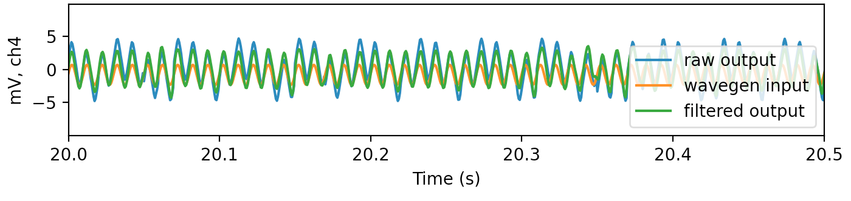

When only filtering using notch filters, there appear to be periodic fluctuations every 0.04 seconds (25 Hz) (shown on top-most plot). Using a bandpass filter from 30-300 Hz gets rid of this artifact (bottom plot). Not sure why this occurs. It would not be practical to implement this bandpass filter when using the FlexsEMG, as sEMG signals range from 20-300 Hz, and using a 30 Hz highpass filter would potentially remove some sEMG signals.

At 100 Hz, sample #7 appears to record twice the amplitude.

**250 Hz:**

****

**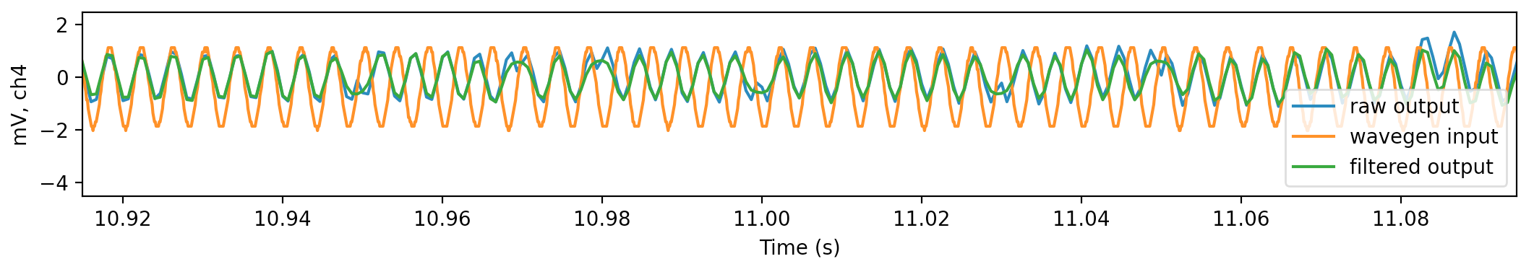**

At 250 Hz, the response seems to drift in and out of phase, resembling a beat frequency. The FFT plot also shows that there are two larger frequency peaks around 250 Hz. In practice, we cannot filter out these frequencies as they fall within the 20-300Hz range for sEMG signals.

**275 Hz:**

Windowed FFT, 275 Hz Signal Response

**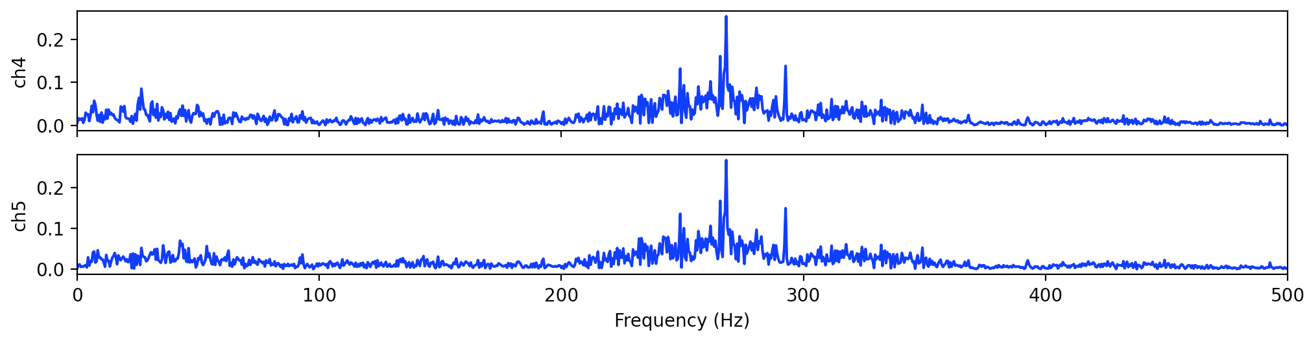**

Signal Amplitude

****

The 275 Hz response is similar to the 250 Hz response. However, this is due to the response having a peak at 270 Hz rather than 275 Hz. This result suggests that the FlexsEMG has a non-linear response to higher frequencies.

C: An unexpected result:

From left to right: 100, 200, and 250 Hz measurements - the 200 Hz measurement can be seen in channels 5 and 6 despite the sin waves only being fed to channel 4. (Come to think of it, the signals should not be in channel 5 either)

FFT magnitude for 100, 200, and 250 Hz measurements



FFT Amplitude

Frequency (Hz)

For reference, here are the channel numbers. Channel 5 does not share any electrodes with Channel 4. However, the pads on the RHD2216 for 4- (labeled 3- on RHD) are extremely close to the 5+ (labeled 4+ on RHD) pad, leading me to think that there is some crosstalk or short between the two electrodes

 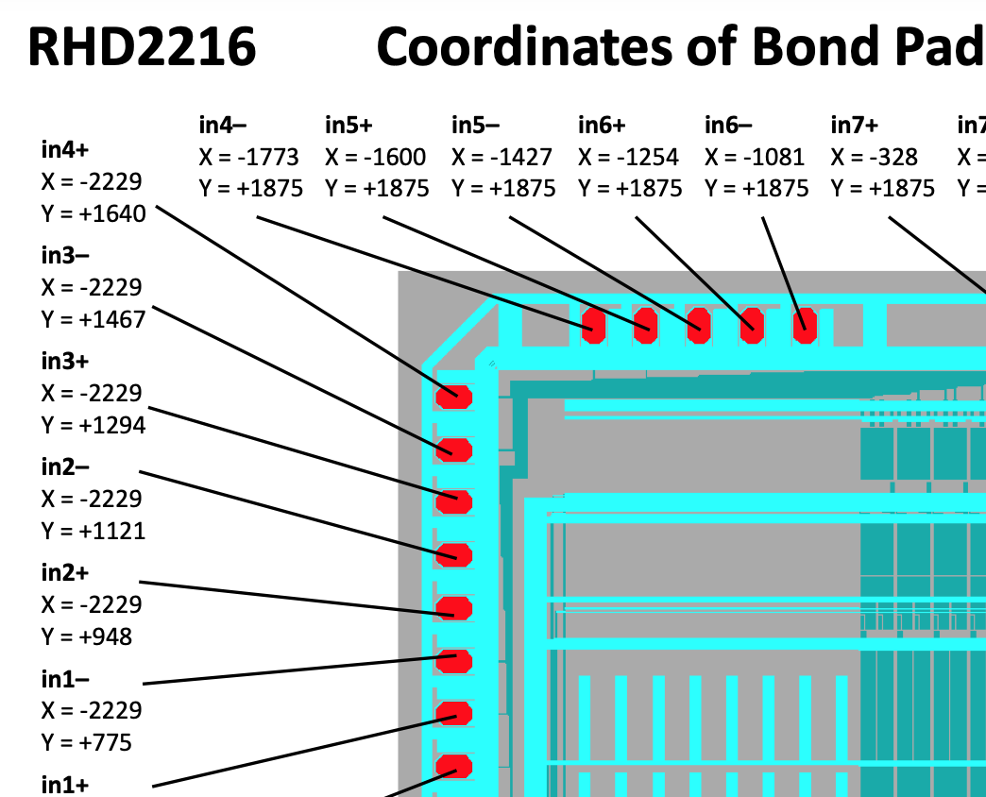

D: Sample #5 Noise Profiles

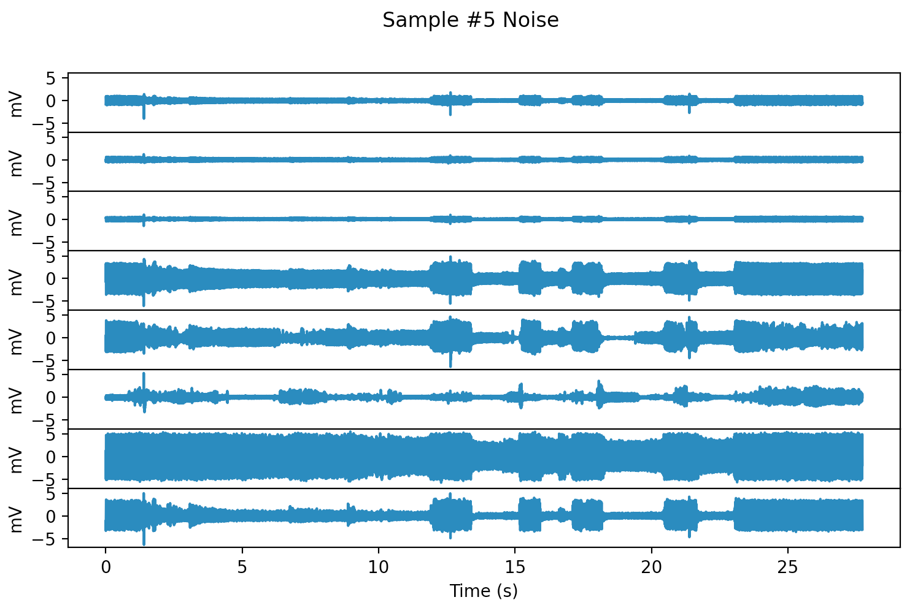 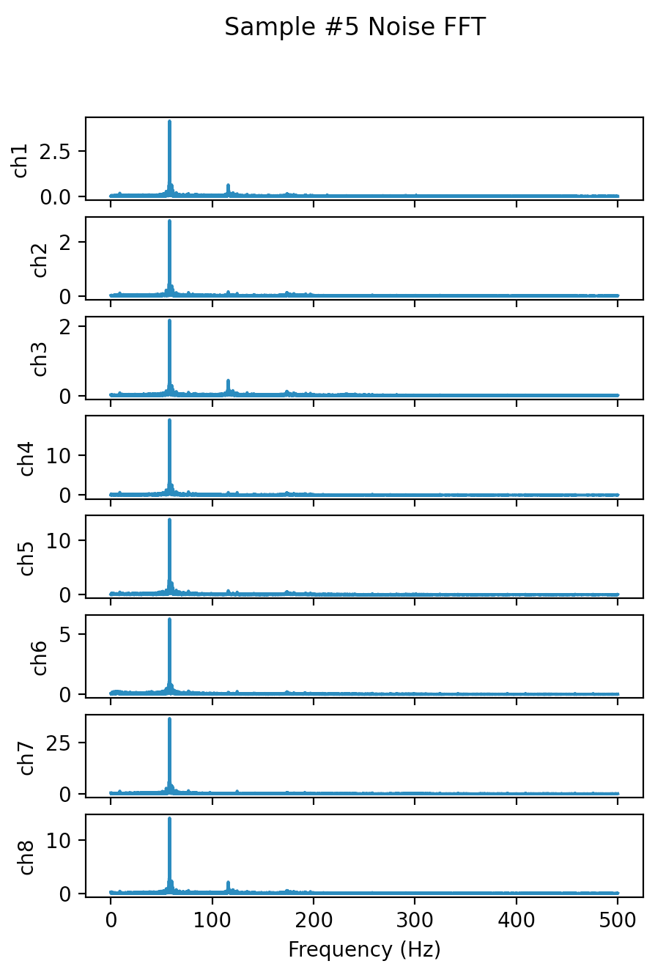

FFT: sharp peak at 58 Hz

E. Can we make a filter for Sample #5?

Looks unlikely, Sample #5 seems to have a response in the same frequency for any input. I’m not sure why this is happening.

250 Hz:

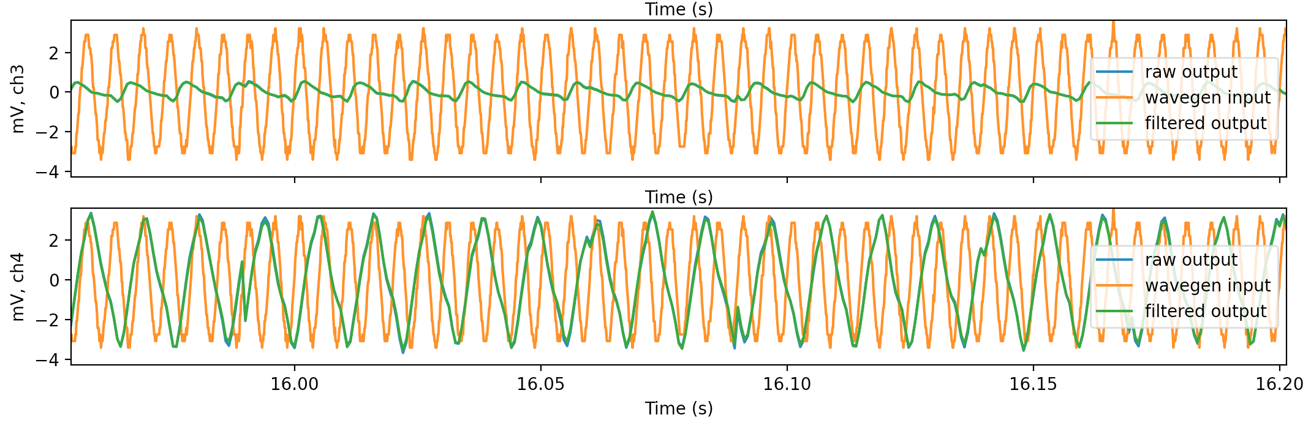

200 Hz:



150 Hz:

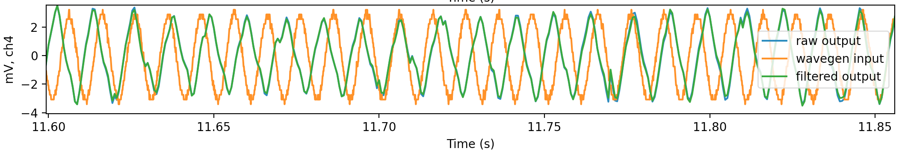

100 Hz:

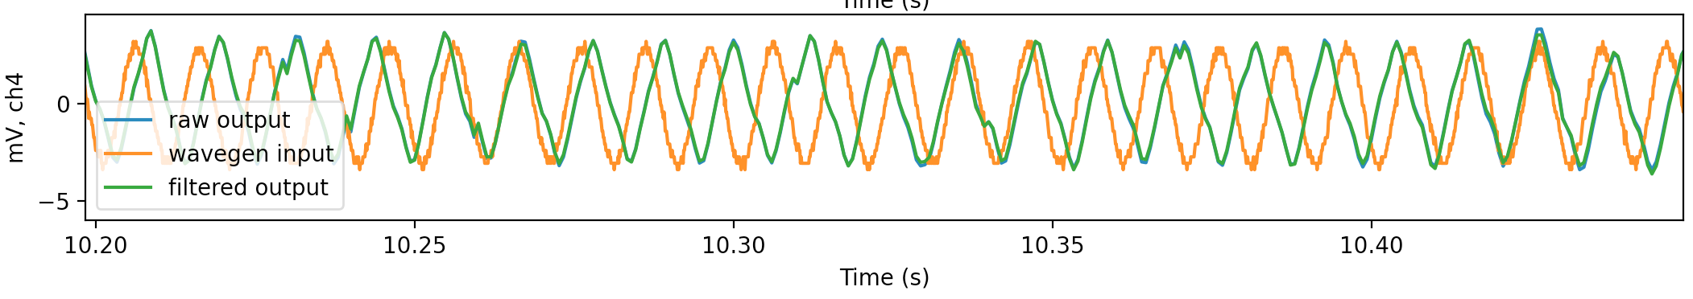

50 Hz:



The above measurements were taken consecutively in the same measurement. The FFT of all measurements combines does not look different from the noise profile.

**FFT Magnitude, Sample #5**

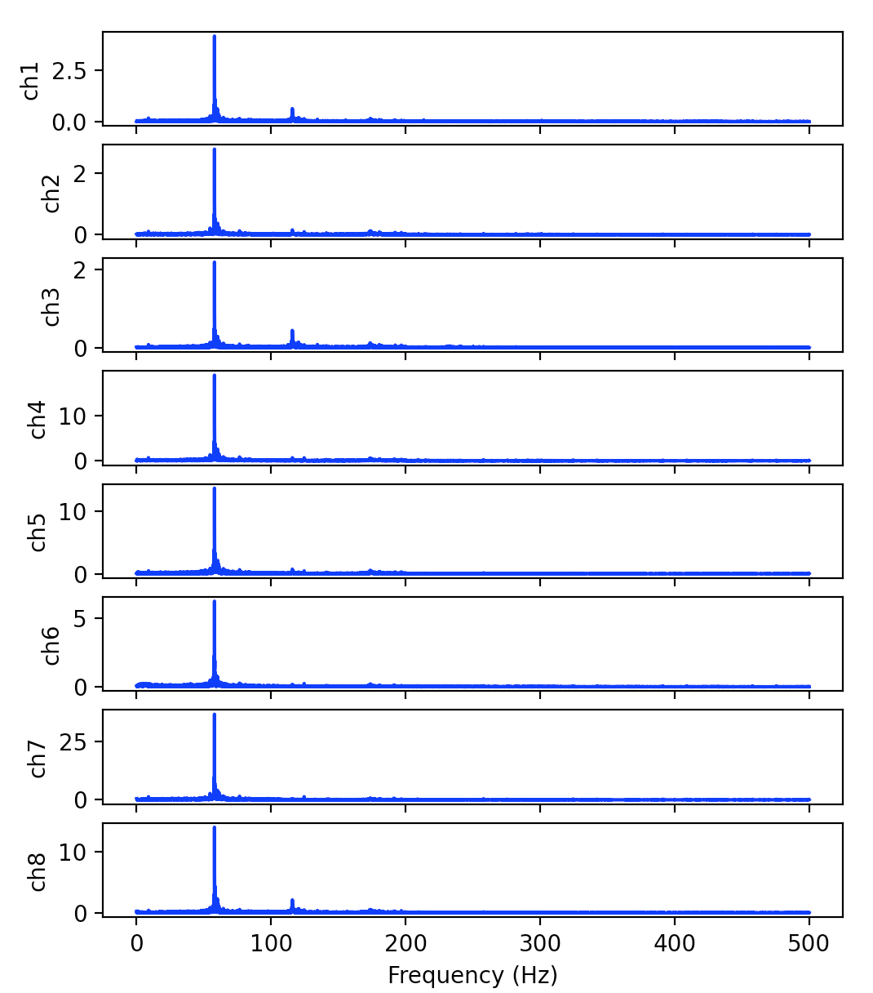

**Conclusions:**

Each FlexsEMG device has its own noise profile - different filters must be created for each device. Frequencies around 250-275 Hz give non-linear responses

1. For Sample #7, feeding a 200 Hz frequency excites a channel in another column?